https://rs.mail.ru/pixel/CjYIgvchQAFIowHgAQEQxvmKVh2xtY1aIC4oAjjXtvjxyxBwAaABz9yi0AO4AbgrkAPP3KLQgwE.gif

**Играем с детьми**

**Игра: «Варим, жарим – готовим».**

**Алгоритмы приготовления**

[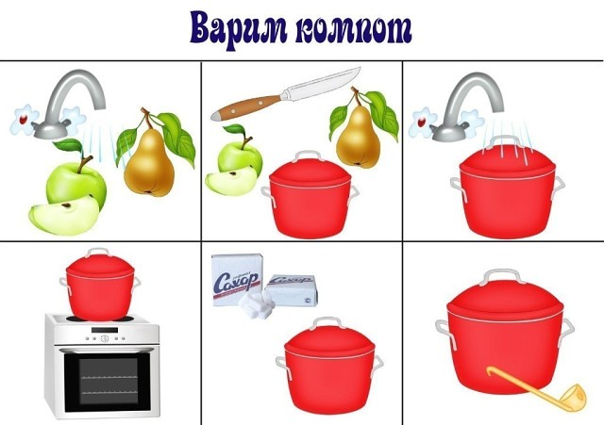](https://ok.ru/dk?cmd=PopLayerPhoto&st.layer.cmd=PopLayerPhotoOuter&st.layer.type=GROUP&st.layer.revNav=off&st.layer.limitedUi=false&st.layer.sphotoIds=862858568900;862858569156;862858569412;862858569668;862858569924;862858570180;862858570436&st.layer.showNav=on&st.layer.photoAlbumId=52717718798532&st.layer.epm=off&st.layer.photoId=862858568900&st.layer.opl=off&st.layer.navStartPhotoId=862858568900&st.layer.sbd=off&st.cmd=userMain&st._aid=GroupTopicLayer_openPhotoLayer)

[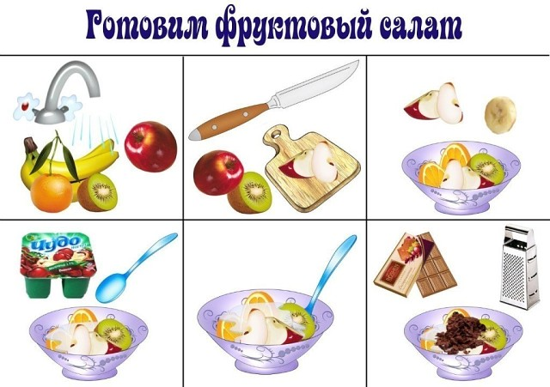](https://ok.ru/dk?cmd=PopLayerPhoto&st.layer.cmd=PopLayerPhotoOuter&st.layer.type=GROUP&st.layer.revNav=off&st.layer.limitedUi=false&st.layer.sphotoIds=862858568900;862858569156;862858569412;862858569668;862858569924;862858570180;862858570436&st.layer.showNav=on&st.layer.photoAlbumId=52717718798532&st.layer.epm=off&st.layer.photoId=862858569156&st.layer.opl=off&st.layer.navStartPhotoId=862858569156&st.layer.sbd=off&st.cmd=userMain&st._aid=GroupTopicLayer_openPhotoLayer)

[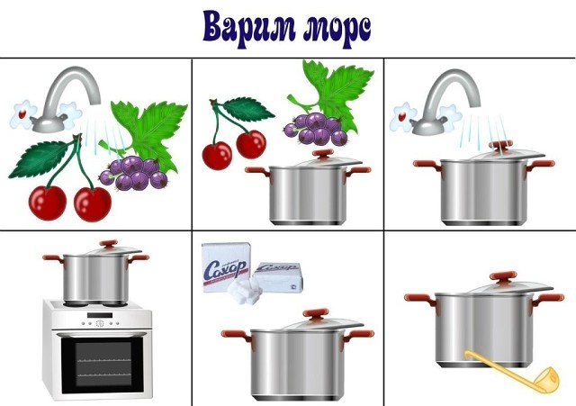](https://ok.ru/dk?cmd=PopLayerPhoto&st.layer.cmd=PopLayerPhotoOuter&st.layer.type=GROUP&st.layer.revNav=off&st.layer.limitedUi=false&st.layer.sphotoIds=862858568900;862858569156;862858569412;862858569668;862858569924;862858570180;862858570436&st.layer.showNav=on&st.layer.photoAlbumId=52717718798532&st.layer.epm=off&st.layer.photoId=862858569412&st.layer.opl=off&st.layer.navStartPhotoId=862858569412&st.layer.sbd=off&st.cmd=userMain&st._aid=GroupTopicLayer_openPhotoLayer)

[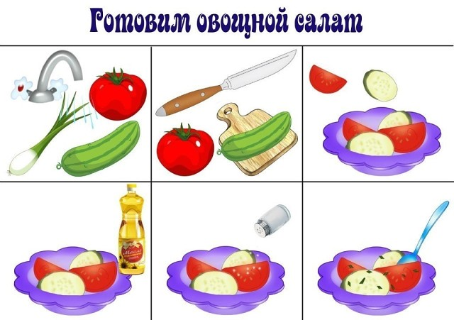](https://ok.ru/dk?cmd=PopLayerPhoto&st.layer.cmd=PopLayerPhotoOuter&st.layer.type=GROUP&st.layer.revNav=off&st.layer.limitedUi=false&st.layer.sphotoIds=862858568900;862858569156;862858569412;862858569668;862858569924;862858570180;862858570436&st.layer.showNav=on&st.layer.photoAlbumId=52717718798532&st.layer.epm=off&st.layer.photoId=862858569668&st.layer.opl=off&st.layer.navStartPhotoId=862858569668&st.layer.sbd=off&st.cmd=userMain&st._aid=GroupTopicLayer_openPhotoLayer)

[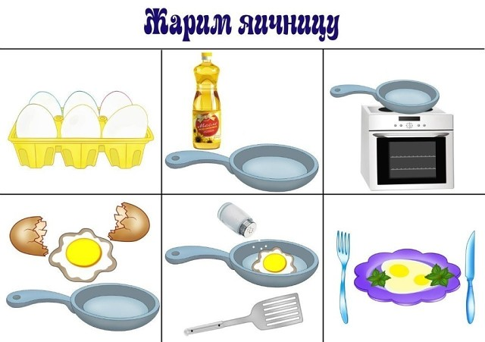](https://ok.ru/dk?cmd=PopLayerPhoto&st.layer.cmd=PopLayerPhotoOuter&st.layer.type=GROUP&st.layer.revNav=off&st.layer.limitedUi=false&st.layer.sphotoIds=862858568900;862858569156;862858569412;862858569668;862858569924;862858570180;862858570436&st.layer.showNav=on&st.layer.photoAlbumId=52717718798532&st.layer.epm=off&st.layer.photoId=862858569924&st.layer.opl=off&st.layer.navStartPhotoId=862858569924&st.layer.sbd=off&st.cmd=userMain&st._aid=GroupTopicLayer_openPhotoLayer)

[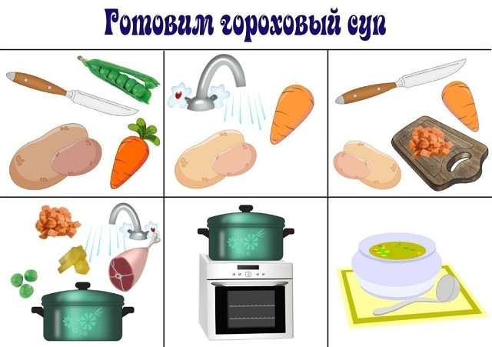](https://ok.ru/dk?cmd=PopLayerPhoto&st.layer.cmd=PopLayerPhotoOuter&st.layer.type=GROUP&st.layer.revNav=off&st.layer.limitedUi=false&st.layer.sphotoIds=862858568900;862858569156;862858569412;862858569668;862858569924;862858570180;862858570436&st.layer.showNav=on&st.layer.photoAlbumId=52717718798532&st.layer.epm=off&st.layer.photoId=862858570180&st.layer.opl=off&st.layer.navStartPhotoId=862858570180&st.layer.sbd=off&st.cmd=userMain&st._aid=GroupTopicLayer_openPhotoLayer)

[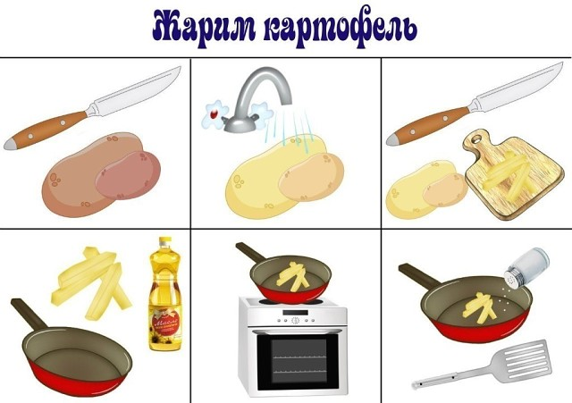](https://ok.ru/dk?cmd=PopLayerPhoto&st.layer.cmd=PopLayerPhotoOuter&st.layer.type=GROUP&st.layer.revNav=off&st.layer.limitedUi=false&st.layer.sphotoIds=862858568900;862858569156;862858569412;862858569668;862858569924;862858570180;862858570436&st.layer.showNav=on&st.layer.photoAlbumId=52717718798532&st.layer.epm=off&st.layer.photoId=862858570436&st.layer.opl=off&st.layer.navStartPhotoId=862858570436&st.layer.sbd=off&st.cmd=userMain&st._aid=GroupTopicLayer_openPhotoLayer)